**CISCO CCNA ACADEMY**

**AICTE CISCO VIRTUAL INTERNSHIP- 2024 REPORT**

**DOMAIN: NETWORK**

**PROBLEM STATEMENT:**

Networking Fundamentals Integration: Students will use knowledge gained from Level 1 to 8 to simulate network environments and visualize the packet flow in those scenarios. The concepts of ARP, MAC (Media Access Control) tables, Switching, IP routing, Routing tables, Static routing and Dynamic routing protocols will all contribute to the representation of packets as they traverse the network.

**LEVEL 1:**

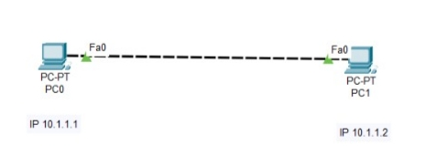

To establish a connection between two PCs and assign specific IP addresses to them. The communication process is examined using the "ping" command.

**OUTPUT:**

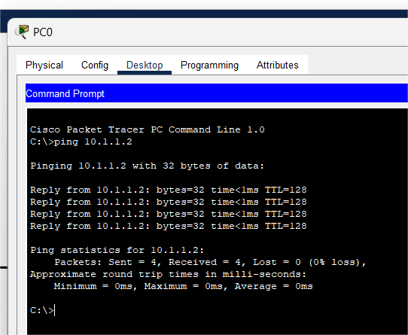

**LEVEL 2:**

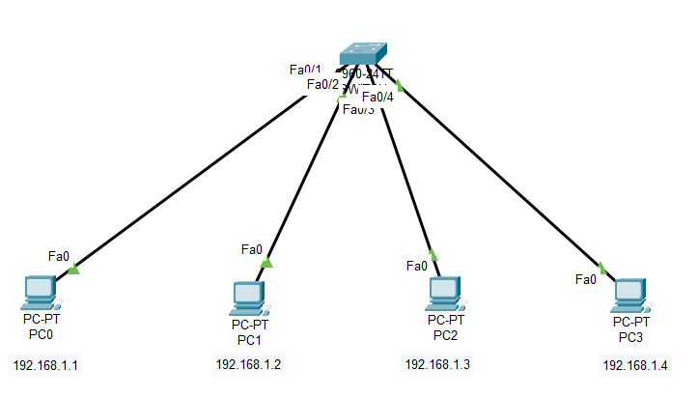

The objective is to establish a connection between multiple computers using a switch and assign unique IP addresses to each computer. The Level involves performing "ping" tests between neighboring computers to verify connectivity.

**OUTPUT:**

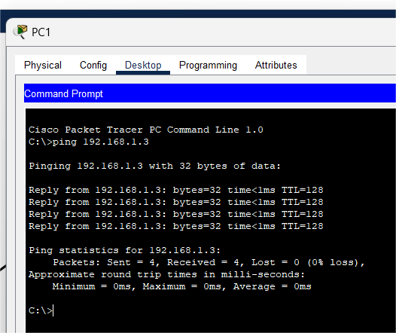

**LEVEL 3 & 4:**

Two computers are connected directly to each other using a wire, and different IP addresses are assigned to them with separate subnets. When attempting to ping one PC from the other, the ping operation fails.the objective is to establish a connection between two computers using a router.

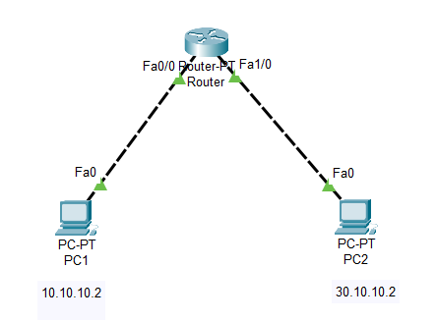

**OUTPUT:**

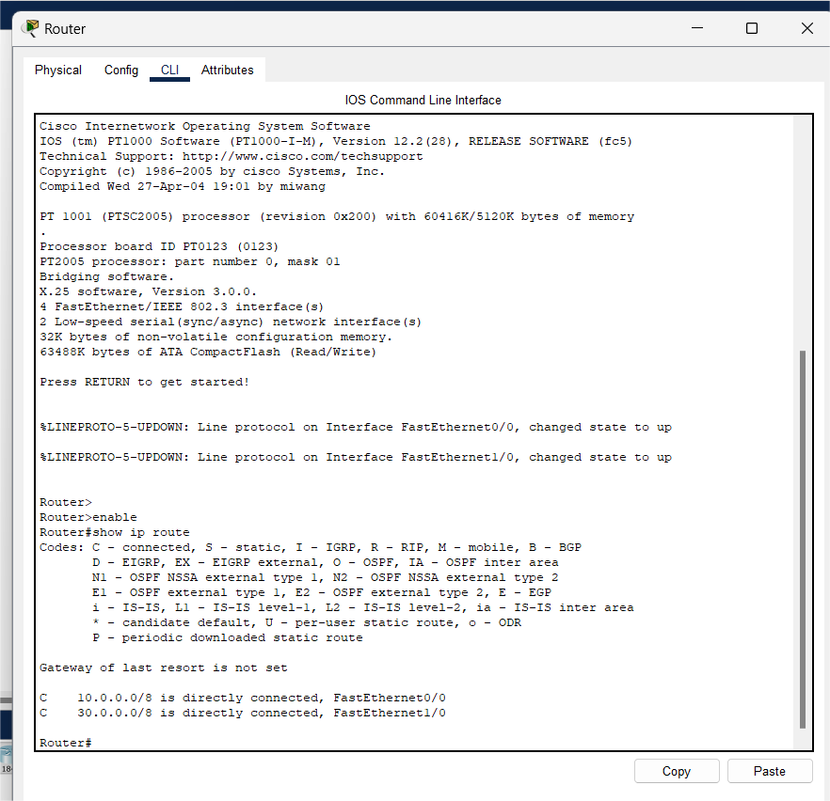

**LEVEL 5:**

The objective is to establish connectivity between multiple computers by utilizing two separate networks, a router, and a switch. The setup involves connecting the computers to the switch, which in turn is connected to the router, thereby enabling communication between the two networks.

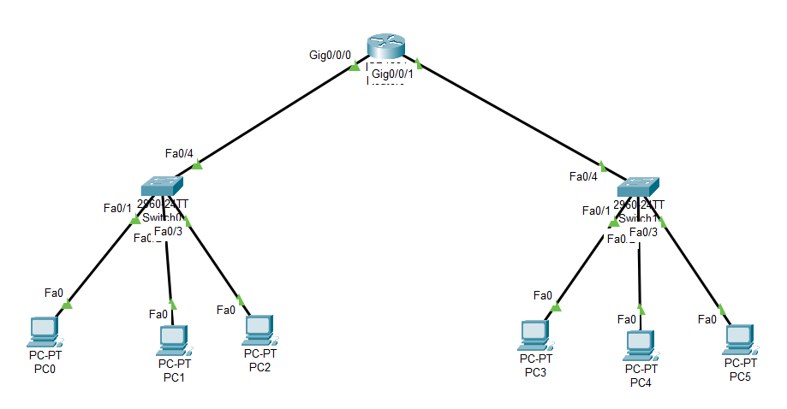

**OUTPUT:**

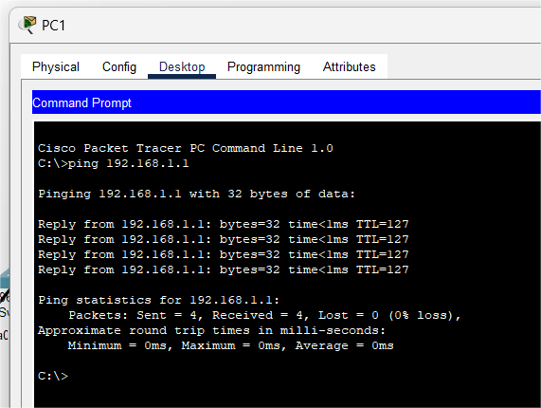

**LEVEL 6:**

The objective is to establish connectivity between different networks using routers and configure static routes to connect multiple networks. Also by utilizing the appropriate router commands, can configure static routes and examine their configuration using the "show ip route" command.

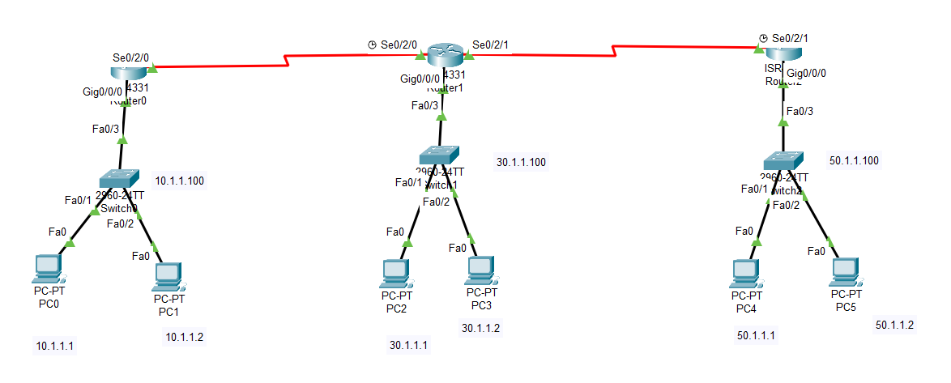

**OUTPUT:**

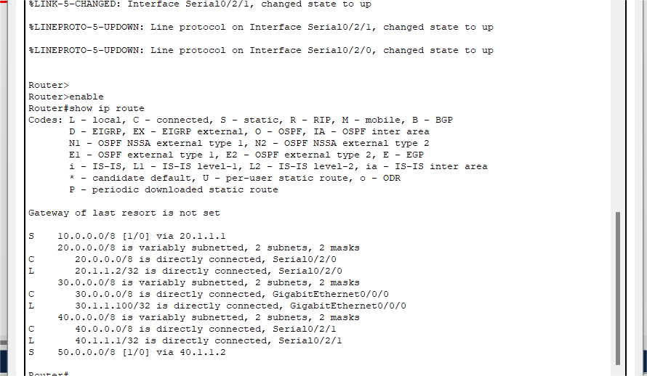

**LEVEL 7:**

The objective is to establish connectivity between multiple networks using routers. Then to configure a dynamic routing protocol, such as OSPF (Open Shortest Path First), on each router in the Level. This focuses on understanding how OSPF operates and how it builds the routing table.



**OUTPUT:**

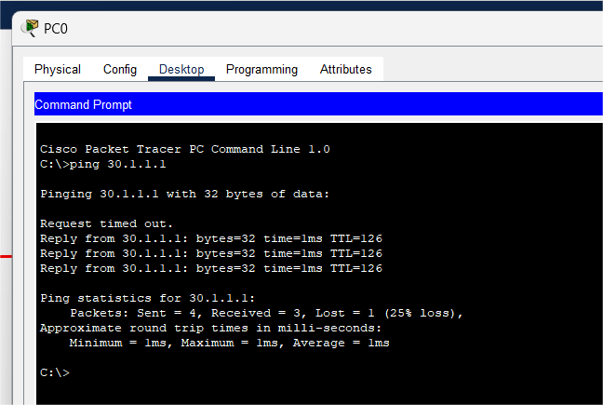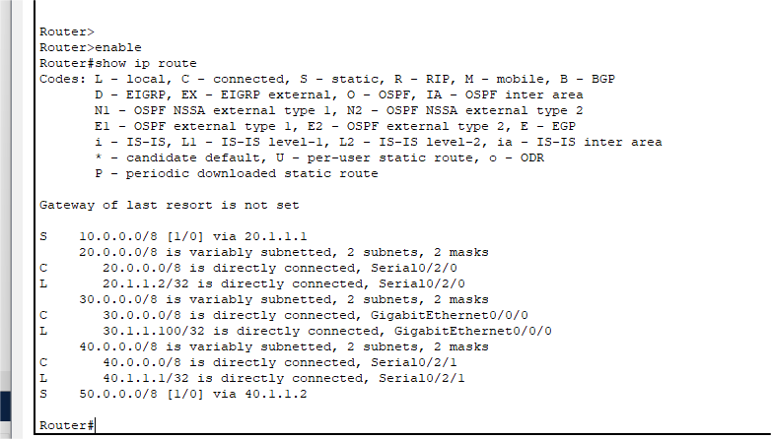

**LEVEL 8:**

The project sets up a network with 3 routers, 2 switches, 2 PCs, a laptop, and a server. Fast Ethernet connects the devices and serial connection between routers. Each end device has an IP address. Routers 3 and 6 serve as primary routers, and Router 4 is the backup. OSPF is configured with unique router IDs. Packet flow to the server is observed by capturing packets and ‘show IP route’ command lists the IP addresses of the network.Ping test confirms connectivity. This project highlights redundancy, dynamic routing, and fault tolerance, demonstrating a scalable and robust network.

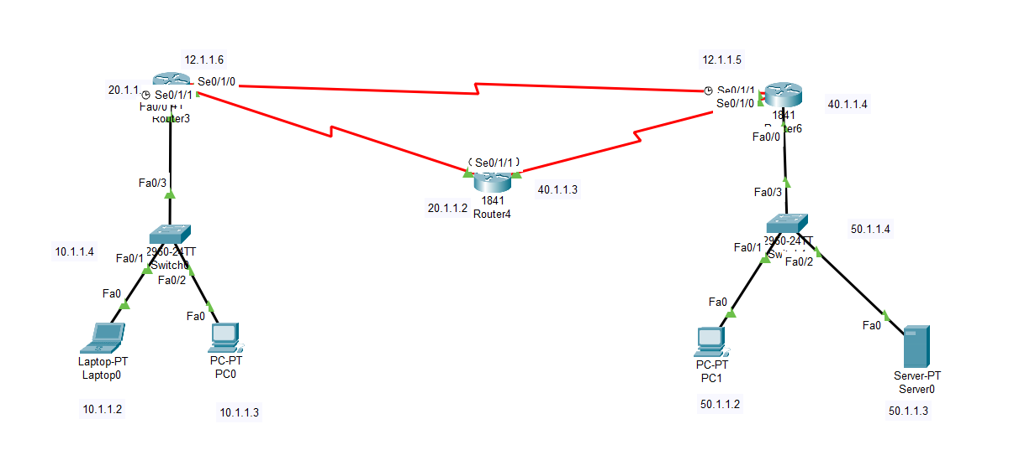

**OUTPUT:**

